

**Final Project Phase 3**

Makenzie Howard, Vidhi Arun Sharma, Willie Watts, Alissa Yang

MET AD 599S O2 - Introduction to Python and SQL for Business Analytics

August 12, 2025

Table of Contents

Executive Summary 3

Part 1: Employee Sales Performance Analysis 3

Part 2: Monthly Sales Trend Analysis 4

Part 3: Product Sales Ranking by Category 5

Part 4: Customer Purchase Behavior Analysis 6

Conclusion 7

# 

# **Executive Summary**

This report presents an analysis of Northwind’s employee sales performance, monthly sales trends, product profitability, and customer purchasing behavior. Analysis of total sales by employees revealed a relatively even distribution of performance with no significant underperformers. The gap between the highest and lowest performer is approximately $3 million, suggesting that small differences in execution accumulate into notable revenue impacts.

Analysis of monthly sales trends shows a consistent seasonal pattern with significant peaks in March, May, July, October, November, and December. The trends highlight the need for targeted marketing and promotional campaigns ahead of peak months.

Analysis of product sales by category shows that top revenue generators do not always result in highest unit sales. The findings support a pricing strategy to prioritize profitability over volume.

Analysis of customer purchase behavior identified two segments: high-AOV customers who place fewer but more valuable orders, and high-volume customers with lower AOVs. Strategic opportunities include loyalty initiatives for high-AOV customers to increase frequency, and upsell tactics for high-volume customers to raise per-order spend.

# **Part 1: Employee Sales Performance Analysis**

To identify top-performing employees based on their total sales, we calculated the total sales amount for each employee. The query calculates the total sales generated by each employee by summing the sales values of their orders and takes into account quantity and discounts while ranking their performance in descending order.

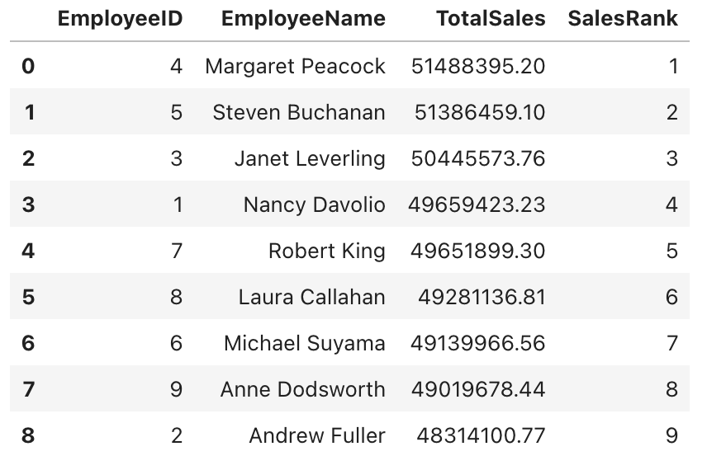

The overall sales distribution is relatively close with no extreme underperformance. This suggests that we are either working with a highly effective sales team or that territory potential is not a factor in total sales. Overall, there is roughly a $3 million difference between the top performer and the lowest performer. Although there is rather consistent performance across all employees, small differences do add up in total revenue. Margaret Peacock and Steven Buchanan are our top 2 performers with very close total sales, so their sales tactics should be further analyzed to apply to the rest of the team in an effort to make up for any differences in performance and revenue. Furthermore, allowing for different incentive programs, such as a competition based program, could also make a difference in overall productivity as well by closing the performance gaps even further.

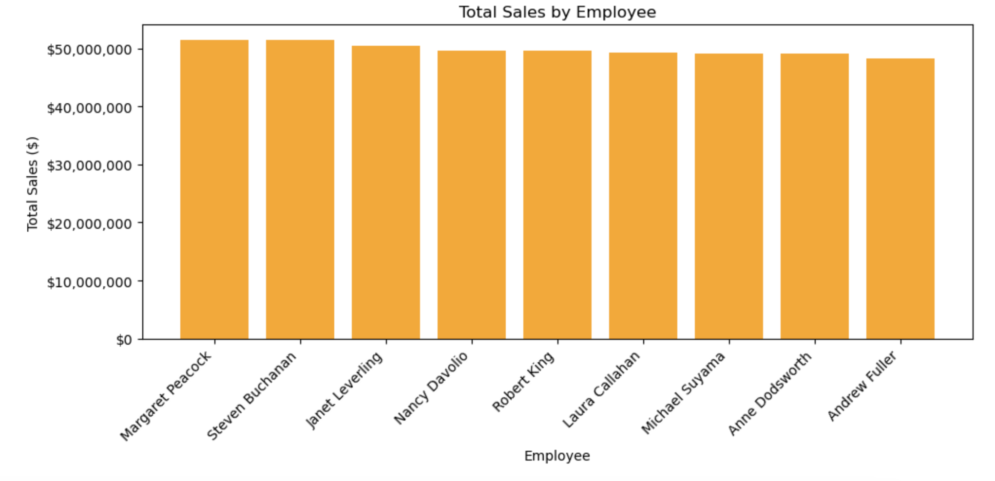

# **Part 2: Monthly Sales Trend Analysis**

We aggregated monthly sales from July 2012 to October 2023 by joining the Orders and Order Details tables to calculate revenue for each month. Month-over-month (MoM) growth was then calculated using SQLite window functions to highlight changes between consecutive months. The analysis reveals a clear seasonal pattern, with pronounced peaks in March, May, July, October, November, and December, often showing MoM growth between 21% and 48%. These months align with major holidays, while the months that follow typically see sharp declines of 21% to 31%. The consistent cycle of holiday-driven demand followed by post-holiday slowdowns suggests the need for targeted marketing, promotional campaigns, and inventory planning in advance of peak months, as well as strategies to sustain sales during slower periods.

**Method:** We executed the Phase 1 monthly sales query directly in Python against northwind.db, aggregating total monthly sales and calculating month-over-month growth using SQLite window functions. The output was saved as CSV, XLSX, and a PNG line graph.

**Insight:**The chart shows pronounced seasonal peaks in March, May, July, October, November, and December, often followed by sharp drops in the following months. This pattern reflects holiday demand cycles, suggesting that inventory and marketing efforts should be front-loaded ahead of these peak months.

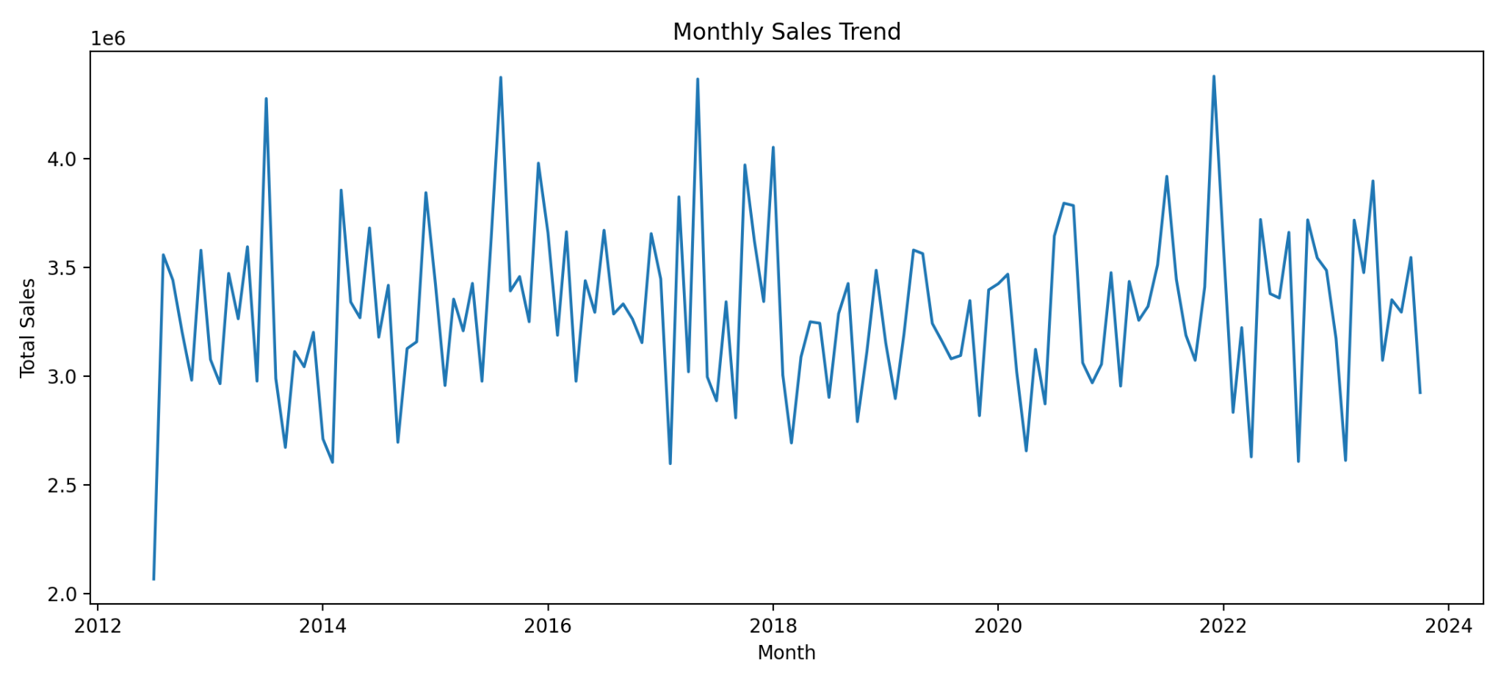

# **Part 3: Product Sales Ranking by Category**

For product sales ranking by category analysis, total sales were calculated for each product by multiplying the unit price and quantity sold. The products were then grouped by category and ranked using RANK(), showing the top three products in each category. The results are shown below:

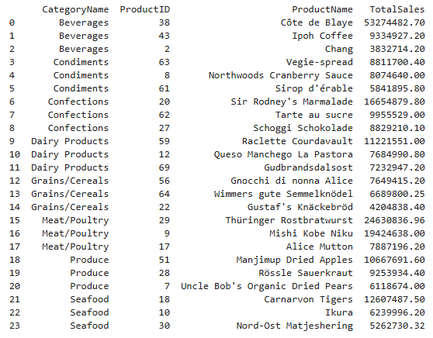

The results show that the top revenue-generating products are not always the highest in unit sales. For example, in Beverages, Côte de Blaye generated the most revenue despite Ipoh Coffee and Chang selling similar or greater quantities. This shows that higher priced products can be more profitable with lower volumes, emphasizing the importance of pricing strategy.

Seasonal analysis shows consistent peaks in March, May, July, October, November and December, followed by sharp declines after the holidays. Based on these findings, it is recommended that Northwind prioritizes high-margin products for marketing and develop a seasonal sales calendar to align with peak demand.

# **Part 4: Customer Purchase Behavior Analysis**

To assess customer purchasing behavior in SQL, we calculated the average order value (AOV) by joining the Orders and OrderDetails tables and computed each order’s totals using UnitPrice, Quantity, and Discount. This process ensured accurate order calculations before determining each customer’s AOV. A common table expression (CTE) and RANK() were used to rank customers in descending order of AOV.

Analysis of Northwind’s customer metrics revealed that Fabrica Inter. Salchichas S.A. (FISSA) holds the highest AOV, yet none of the top ten customers by AOV appear in the top ten for either total revenue or total order count. This contrast is notable when compared to B’s Beverages, which leads in both total revenue and order volume, but ranks significantly lower in AOV. Similarly, the top three customers for total revenue—B’s Beverages, Hungry Coyote Import Store, and Rancho Grande—rank 15th, 19th, and 20th in AOV respectively, while holding top-ten positions in total order count (1st, 6th, and 10th). This suggests two distinct customer segments: those driving value through fewer, high-value orders versus those generating value through frequent, lower-value transactions.

Particular focus was given to customers ranking 2nd, 3rd, 5th, 8th, 12th, 15th, and 17th in AOV. Most of these customers also maintain higher-than-average totals for both revenue and order count, with the exception of La corne d’abondance, which has lower total revenue than FISSA but matches its total orders at 155 (see Appendix D.). This dual metric perspective offers strategic opportunities: high-AOV customers can be nurtured with loyalty incentives and cross-sell promotions to increase order frequency, while high-volume, lower-AOV customers may benefit from targeted upsell strategies aimed at increasing per-order spend. By segmenting customer engagement strategies in this way, Northwind can better align marketing, sales, and product mix decisions to maximize both revenue and profitability across different customer profiles.

# **Conclusion**

The analysis of Northwind’s sales performance, seasonal demand patterns, product profitability, and customer purchasing behavior reveals a consistently strong but improvable sales operation. Employee performance is evenly distributed, with only a modest $3 million gap between the highest and lowest performers, indicating that small performance enhancements could yield substantial revenue gains. Seasonal trends are predictable, with clearly defined peak months that should guide both marketing and inventory planning. Product profitability analysis underscores the value of prioritizing high-margin offerings over sheer sales volume, while customer segmentation highlights distinct opportunities to grow revenue through targeted engagement strategies. By aligning employee development, promotional timing, pricing, and customer-focused initiatives, Northwind can strategically strengthen its market position, increase profitability, and sustain growth across both high-value and high-volume customer segments.